# Steps to install scripted VMs

Ensure .NET 4.7.2 or later is installed

Check version:

1. From the **Start** menu, choose **Run**, enter *regedit*, and then select **OK**.

You must have administrative credentials to run regedit.

1. In the Registry Editor, open the following subkey: **HKEY_LOCAL_MACHINE\SOFTWARE\Microsoft\NET Framework Setup\NDP\v4\Full**. If the **Full** subkey isn't present, then you don't have the .NET Framework 4.5 or later installed.

**Note**

The **NET Framework Setup** folder in the registry does *not* begin with a period.

1. Check for a DWORD entry named **Release**. If it exists, then you have .NET Framework 4.5 or later versions installed. Its value is a release key that corresponds to a particular version of the .NET Framework. In the following figure, for example, the value of the **Release** entry is *378389*, which is the release key for .NET Framework 4.5.

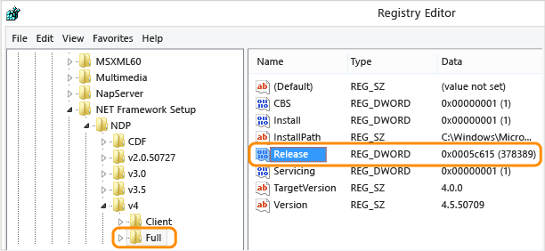

Important

The following table lists the keys of released versions of the .NET Framework only. It doesn't list the keys of preview or pre-release versions.

.NET Framework version Value of the Release DWORD

.NET Framework 4.5 All Windows operating systems: 378389

.NET Framework 4.5.1 On Windows 8.1 and Windows Server 2012 R2: 378675

On all other Windows operating systems: 378758

.NET Framework 4.5.2 All Windows operating systems: 379893

.NET Framework 4.6 On Windows 10: 393295

On all other Windows operating systems: 393297

.NET Framework 4.6.1 On Windows 10 November Update systems: 394254

On all other Windows operating systems (including Windows 10): 394271

.NET Framework 4.6.2 On Windows 10 Anniversary Update and Windows Server 2016: 394802

On all other Windows operating systems (including other Windows 10 operating systems): 394806

.NET Framework 4.7 On Windows 10 Creators Update: 460798

On all other Windows operating systems (including other Windows 10 operating systems): 460805

.NET Framework 4.7.1 On Windows 10 Fall Creators Update and Windows Server, version 1709: 461308

On all other Windows operating systems (including other Windows 10 operating systems): 461310

.NET Framework 4.7.2 On Windows 10 April 2018 Update and Windows Server, version 1803: 461808

On all Windows operating systems other than Windows 10 April 2018 Update and Windows Server, version 1803: 461814

.NET Framework 4.8 On Windows 10 May 2019 Update: 528040

On all others Windows operating systems (including other Windows 10 operating systems): 528049

## Ensure Az PS module is installed

From Power Shell:

Install-Module –Name Az –Scope CurrentUser –AllowClobber

Roadmap:

Ensure all developers have:

1. .NET 4.7.2 or later installed
   1. Are there raminfcations to other dev activities if a later .NET is installed?
2. Latest Azure (Az) Power Shell components installed

1a – seek advice from Windows team regard policy

Seek advice from lead devs on any possible issues from a later .NET installation

2 – Blanket or ad-hoc rollout of Az components. Go ad-hoc to avoid disruption.

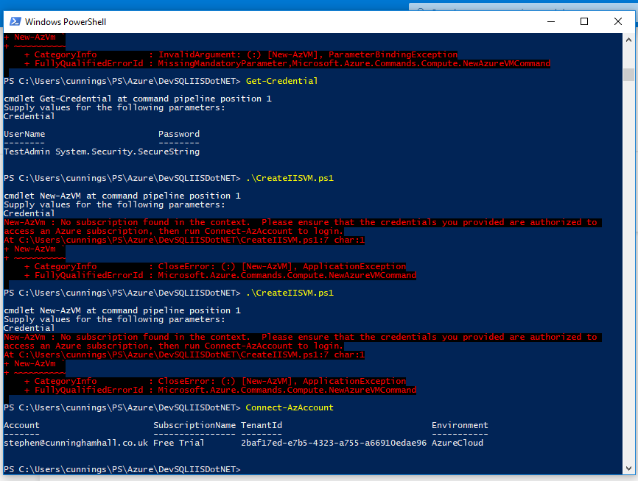

Have to connect your Azure login to the Azure command module using the Connect-AzAccount – this will create a binding.

The actual Credentials prompt is asking for a NEW login name and password that will be applied to the VM once created.

TestAdmin

TestAdmin1234